CMR TECHNICAL CAMPUS

UGC AUTONOMOUS
Accredited by NBA & NAAC with ‘A’ Grade Approved by AICTE, New Delhi and JNTU Hyderabad

Department of Computer Science and Engineering
TITTLE


This project presents an RFID-based identification and alert system using Arduino UNO for efficient and reliable tag detection. It uses an RC522 RFID reader and multiple RFID tags to uniquely identify users or locations. When a tag is scanned, its unique ID is sent to the Arduino for verification with stored authorized IDs. A green LED indicates valid access, while a red LED signals unauthorized detection. An additional LED and buzzer provide visual and audible alerts. The system operates on a rechargeable power supply for portability and continuous use. It is cost-effective and suitable for applications like smart tourist systems, access control, attendance monitoring, and security verification.
 | 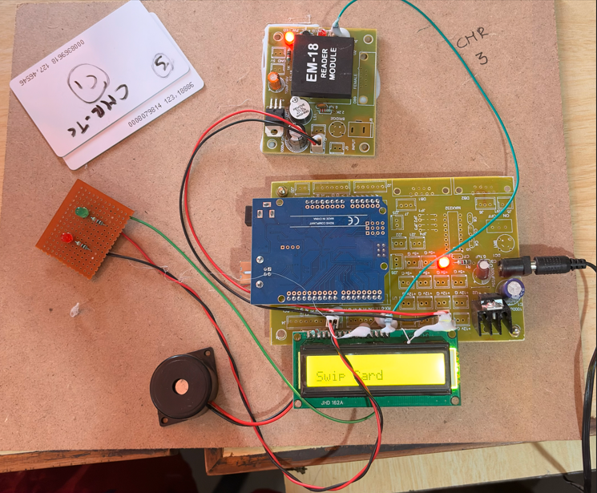


The RFID and Bluetooth-based Tourist Service Prototype is a smart guidance system designed to provide automated information to tourists at different locations. RFID tags installed at tourist spots detect nearby visitors, and relevant details are delivered to their Bluetooth-enabled devices. The system offers location-based information, navigation support, and multimedia content. It reduces the need for manual guides while improving visitor experience. This solution is cost-effective and suitable for museums, heritage sites, and tourist attractions.
  Traditional tourist services rely on static methods like physical maps, printed guides, and on-site information kiosks, which often lead to delays, language barriers, and inefficient navigation in crowded areas. These approaches lack real-time interaction, personalization, or integration with digital devices, resulting in higher operational costs for tourism boards and suboptimal visitor satisfaction.​ | Batch-5:  S.VAISHNAVI 247R1A05C3  J.RAHUL GOUD 247R1A0588  C.AJITH 247R1A0577
FACULTY SUPERVISOR
R SANDHYA
Assistant Professor.
The RFID and Bluetooth Based Tourist Service Prototype improves tourism using smart, location-aware technology. It combines RFID for identification and Bluetooth to deliver personalized information and navigation support. The system reduces reliance on guides, overcomes language barriers, and enhances accessibility. It is cost-effective, scalable, improves visitor engagement, and can be expanded with GPS, mobile apps, and cloud-based analytics.

